3D-Student Science Performance
Author: Pearl Lam
Grade: 2nd grade |  |  |  | Lesson Title:  Erosion Changes Earth’s Surface
Lesson Topic: Impact of Wind and Water on Land
Performance Expectations (Standard) from State Standards or NGSS:

2.E1U1.4: Observe and investigate how wind and water change the shape of the land resulting in a variety of landforms.
Lesson Performance Expectations:
- Students observe and investigate how wind and water change the Earth’s surface using models.
- Students plan and carry out an investigation to observe how wind and water impact the movement of earth materials on Earth’s surface.
- Students communicate explanations based on evidence about how wind and water change Earth’s surface, and what forms of energy are involved in the movement of earth materials.
Engage  Explore  Explain  Explore  Explain  Elaborate  Explore  Explain  Elaborate | Student Science Performance  Investigative Phenomenon: The sand and soil in the playground changes after it rains.  Gather  - Students develop questions to investigate the changes in the land caused by wind and water.  (Teaching suggestions: Teachers show photos of erosion from places outside. See Appendix B for suggested photos. Teachers can also use their own photos. Teacher can ask, “I wonder if this happens in the playground?” Teachers take students outside to the playground and observe phenomena. Make sure that students make observations in different areas of the playground (sand and soil). Students make observations to gather information about erosion. Students develop their own questions – in notebooks, pairs, groups.)  Reason  - Students construct preliminary explanations on how wind and water change the land. Teacher can use prompts below for students:  Class Discussion:  Q: What do we notice in sandy areas?  Q: What do we notice in areas where soil or dirt is?  Q: What could cause the sand or soil to look like it did? (Cause and effect)  Q: What were some differences in the way sand and soil looked?  Q: What are some different landforms we noticed in the playground?  Q: Have you ever seen any effects that rain has on the land?  Q: What do you think would happen to sandy areas when it is windy?  Q: What different kinds of earth materials exist, and where?  Communicate  - Students work in table groups to develop one explanation based on evidence about how water (and wind) cause changes to the land.  (Teaching suggestions: Students can also draw their interpretations of what they saw in their notebooks individually or make posters as groups.)  Gather  Investigative Phenomenon: Water erodes land much faster than wind.  - Students plan and carry out an investigation using a model to show how wind and water cause land to change over time.  (Teaching suggestions: Students will conduct an erosion experiment as a class. The day before, use Dixie cups or Tupperware with wet sand and gravel in place of cornmeal to build landform model. Conduct the experiment the next day when the models have dried. Watch experiment video: https://mysteryscience.com/water/mystery-3/erosion-earth-s-surface-landforms/114#slide-id-2250  1 trial will be done as a class, and then 2 more trials will be done as groups. In this experiment, a “mountain” molded from earth materials found outside will be placed on a table. A cup with a hole will be placed on top.  In the class experiment, 1 volunteer will “make it rain” by pouring water in the cup. 1 volunteer will make “wind” by blowing through a straw. Before conducting the experiment, here are questions the teacher can ask, “What do you think will happen to the land after it rains or gets windy? Do you think these earth materials will move?” Note: For wind to have an effect, the model should be dry with loose earth material on top. Teacher can write these responses on the board on a T-chart under “Predictions”. Next, the entire class will make observations about the “mountain” as water and wind impact the “land” in the experiment. To evaluate the results, the teacher can ask, “Why do you think the earth materials moved? How did the shape of the land change?” Teacher can write these responses on the board on a T-chart under “Results”  In the group experiments, students will focus on observing the effects of wind and water on land, and the movement of Earth Materials. In the next Reason section, students will record and analyze their results in Venn Diagrams.)  Reason  - Students construct an explanation based on evidence about how wind and water caused the observed changes to the land.  (Teaching suggestions: In table groups, students will create a Venn Diagram on butcher paper. The Venn Diagram will compare the effects of wind and water on land. On the same butcher paper, students will write an explanation about how wind and wind caused changes in the landform. Students should start thinking about how and what energy is involved in the movement of earth materials and include these ideas in the explanations. Students can also refer to the class T-chart for data.  As students work independently, the teacher can walk around the classroom and guide each group as needed. See below for suggested questions to guide each group’s thinking.)  Venn Diagram: Effects of Wind and Water on Land  Q: What did you notice about how water changed the land?  Q: What did you notice about how wind changed the land?  Q: What type of matter are land areas made of?  Q: Did the earth materials move?  Q: How did the earth materials move?  Q: What caused the earth materials to move?  Q: What energy might be involved in the movement of earth materials?  Q: How might energy be involved in the movement of earth materials?  Q: Which had a bigger impact on the surface of your model, wind or water? How do you know?  Q: Which do you think takes more time to erode land, wind or water?  Communicate Reasoning  - Students present their explanations based on evidence about how water causes changes to the land.  - Students present their explanations based on evidence about how wind causes changes to the land.  Investigative Phenomenon: Erosion causes landforms in our community.  Gather  - Students apply the information that they have gathered and obtained on how wind and water can cause the land to change.  Outdoor field trip: If possible, students will take a walk at an outdoor site (streams, wetlands, parks) and search for, observe, and analyze different landforms. Alternatively, students can observe the school grounds or different pictures of erosion placed in different places in the classroom.  - Students will make observations about the structure of landforms and gather evidence for how landforms vary in shapes and sizes in Earth’s natural land system.  - Students will also make observations and predictions about how earth materials move, and what forces from energy caused earth materials to move.  (Teaching suggestions: Students first gather as a class around 1 area with evidence of erosion, observe the shape and size of landforms, and brainstorm causes of erosion. Students record their observations of the erosion site and make predictions about the causes of erosion in their science notebooks. Students will draw pictures of their observed landforms in their science notebooks. Next, students can continue exploring in group and record their observation, draw pictures of their observed landforms, and write predictions about the causes of erosions in the observed landforms in their notebooks.)  Reason  - Students will construct an explanation based on evidence that demonstrate high and low energy forces, and the causes and the effects they produce on the land.  - Students will construct a model based on evidence within their small groups.  (Teaching suggestion: Students return to the classroom and divide into small table groups. Students will work in table groups to brainstorm the causes of the effects that they observed. These causes can include different results of energy (e.g. how heat energy from the sun causes weather), and how the different forces of these results change landforms differently. After students brainstormed, they will be reminded of the energy they expended to cause the observed phenomena in their models from the in-classroom erosion experiment. Forms of energy include sunlight energy or energy from the movement of water and wind. In this lesson, the force from energy can be described as “high” or “low.” Students should discuss and explain how high and low forces from energy impacted the land area and moved earth materials.  For example, a sprinkle would be considered a “low” force from energy whereas a rainstorm would be considered “high” force from energy. Other examples include the loss of energy (“very low”) from freezing, which could cause breaks in landform, or the gain in energy from the Sun could dry out soil, or energy from strong winds (“very high”) that could cause earth material to crumble.  Students will use the explanations from the previous Reasoning section to develop their model to demonstrate high and low energy causes and their effects on land.)  Communicate Reasoning  - Students present their models that explain to the class about how high and low energy forces impact landforms and move earth materials.  (Teaching suggestions: The class comes back together and a representative from each group moves to a new group and share their group’s picture model and their explanations about how high and low forces from energy impacted the landform and moved earth materials. This is like a science convention- see BEETLES video for an example of how to arrange a convention, from 5:39 to 8:32: https://www.youtube.com/watch?v=hu6Vf3mo940&t=5m39s)
Elicit Evidence of Learning: Students develops a model supported by evidence that explains how wind and water impacts the movement of earth materials, thereby causing changes in the land.
Evidence of Student Proficiency  The surface of Earth can change over a few hours or more gradually over thousands of years. Studying these changes shows that erosion has changed the surface of Earth. Examples of events that change Earth’s surface quickly can include volcanoes. Events that occur over a longer period are the formation of mountains.  Students focus on wind and water and describe that both change the dirt but the water washes much more off the dirt. |  | Range of Typical Student Responses  Full Understanding: Water causes the most changes to the surface of the land in a short time. The water was able to change the surface of the land by moving earth materials quickly and causing ruts (like canyons or valleys) and indents to form on the surface of the landform we created, while the wind did not have a noticeable impact on our landform.  The amount of energetic force also impacts how a landform changes. For example, a monsoon will erode land surfaces more quickly than a light rain. The water also made the surface of our landform smoother. Based on our data, we have evidence that water makes more changes to the surface of land than wind.  Partial understanding: Wind and water cause erosion. The water causes more erosion than wind because it is heavier.  The student explains that wind and water can cause a change in the land, but does not have clear evidence of energy to support the explanation.  Limited understanding: When we washed water over the dirt we got a lot of dirt to wash off, but when we turned on the fan only a little dust blew off the dirt, but not as much as water.  The student provides the evidence but does not explain the phenomenon. |  |  | Acting on Evidence of Learning  Actions for students who demonstrate a partial or limited understanding that water causes change to the surface of land include students holding a handful of sand or dirt making a fist around the particles as the teacher pours water from a pitcher onto the sand or dirt. Students then can see how the sand/dirt moves. Students again hold the sand or dirt in hand makes a fist around the particles and the teacher can blow through a straw to try to move the particles.  Extensions of learning for students who display a full understanding are students can be given an opportunity to independently plan and conduct an investigation of different wind strengths (using a fan and blow dryer vs a straw) and water amounts (a cup of water vs a pitcher of water) over time.
SEP, CCC, DCI Featured in Lesson |  |  | Science Essentials
Science Practices |  |  | Develop questions about erosion and how erosion occurred.  Investigate how wind and water change landforms.  Construct explanations about how wind and water cause changes in Earth’s surface, and how energy is involved in the movement of earth materials.  Develop and use models to explain how wind and water cause erosion, and how energy is involved in the movement of earth materials.  Communicating information.
Develop questions
Plan and carry out investigation
Construct explanations
Develop and use models
Communicating information
Crosscutting Concepts |  |  | Energy causes weather like wind and rain, which can move earth materials.  Earth materials can move differently depending on how forceful that result of energy is (referred to as “force” of energy).  Erosion by water may occur faster than erosion by wind.
Energy and Matter
Cause and Effect
Disciplinary Core Ideas |  |  | The Earth and its land systems and landforms are composed of earth materials. Wind and water are two causes for land erosion. Different energy forces, high or low, can impact land different.
Earth and Space: Earth’s systems

Appendix A - Student Prompts for the Lesson
Phenomenon: A model of a land area changes after rain and wind.

Group Performances:

- Students develop questions to investigate the changes in the land caused by wind and water.

Class Discussion:

- Students construct preliminary explanations on how wind and water change the land. Teacher can use prompts below for students:

Group Performances:

- Students work in table groups to develop three explanations based on evidence about how water (and wind) cause changes to the land.

Individual Performances:

None

Phenomenon: Water erodes land much faster than wind.

Group Performances:

- Students plan and carry out an investigation using a model to show how wind and water cause land to change over time.
- Students construct an explanation based on evidence about how wind and water caused the observed changes to the land.
- Students present their summaries by their table groups to share their explanations based on evidence about how water causes changes to the land.
- Students present their summaries by their table groups to share their explanations based on evidence about how wind causes changes to the land.

Class Discussion:

None

Individual Performances:

None

Phenomenon: Erosion causes landforms in our community.

Group Performances:

- Students apply the information that they have gathered and obtained on how wind and water can cause the land to change.
- Students will make observations about the structure of landforms and gather evidence for how landforms vary in shapes and sizes in Earth’s natural land system.
- Students will also make observations and predictions about how earth materials move, and what sources and forms of energy cause earth materials to move.
- Students will construct an explanation based on evidence that demonstrate high and low energy causes and the effects they produce on the land.
- Students will construct a model based on evidence within their small groups.
- Students present their simple models that explain to the class about how high and low energy sources impact landforms and move earth materials.

Class Discussion:

None

Individual Performances:

None

Appendix B – Photos of Erosion

Photo 1: (Surface of the beach) | 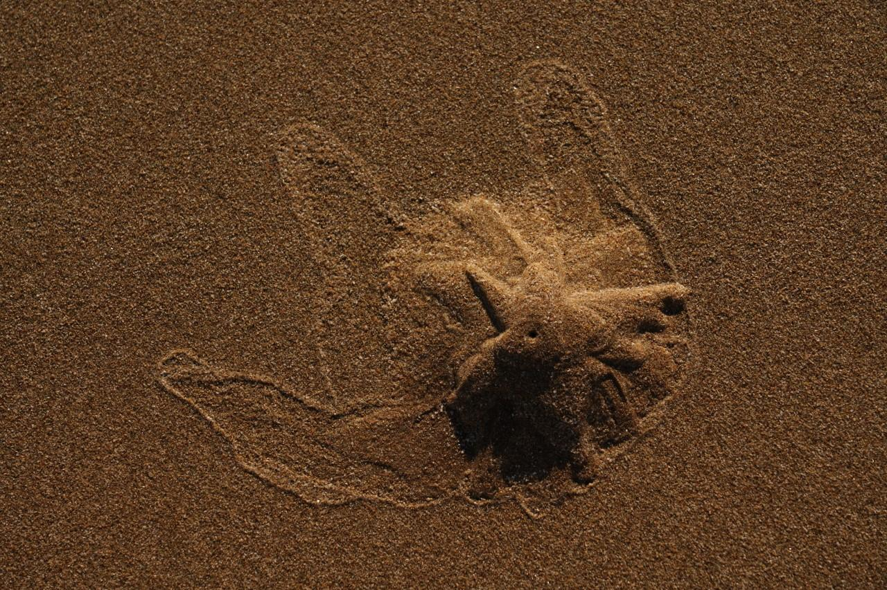
Photo 2:  (Surface of the beach) | 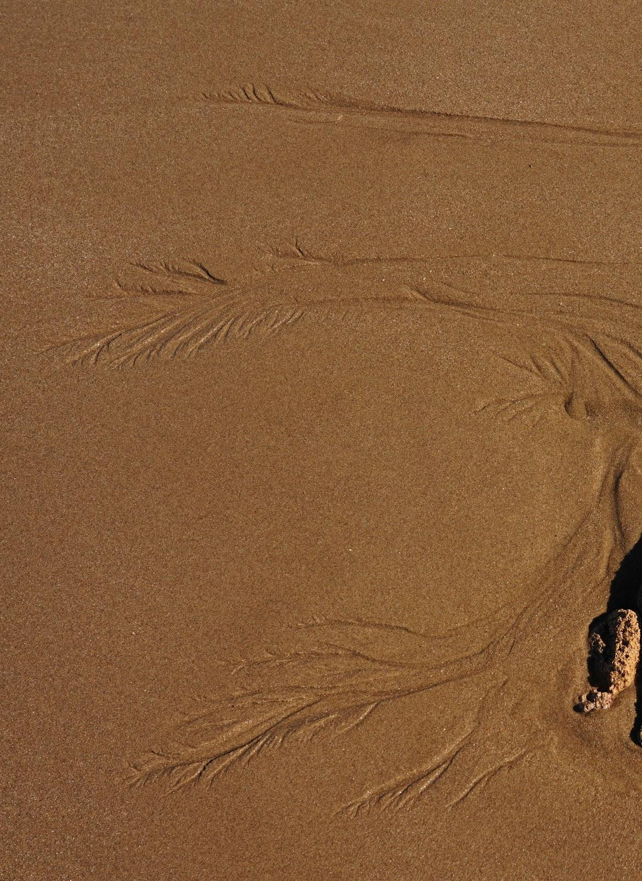
Photo 3:  (Along a pathway in a park) | 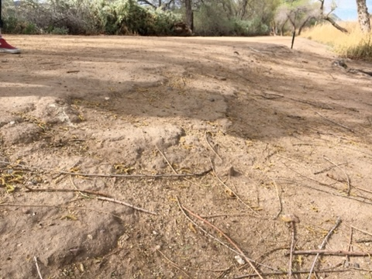
Photo 4:  (Pathway in a park) | 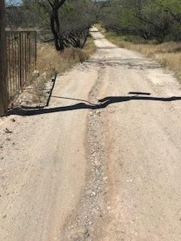
Photo 5:  (Area in a park) | 